A000-US-IN-Vanderburg Co.-Pipe-Duck Effigy Platform-Sterling Pipestone, IL, Hopewell-c 50 CE

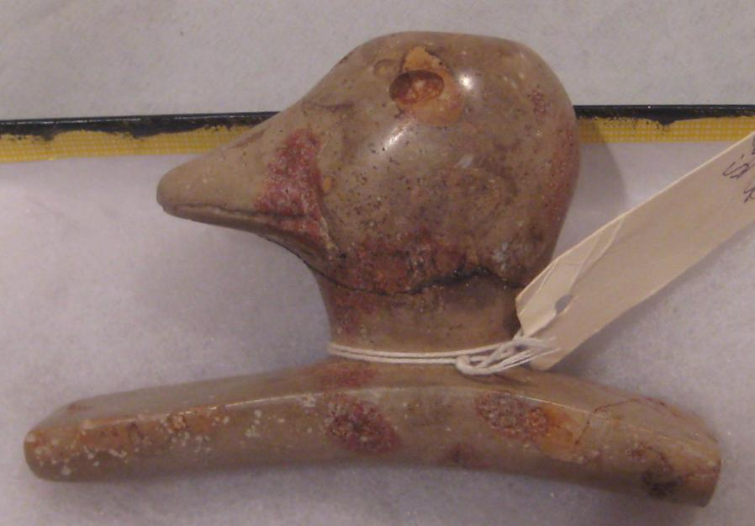

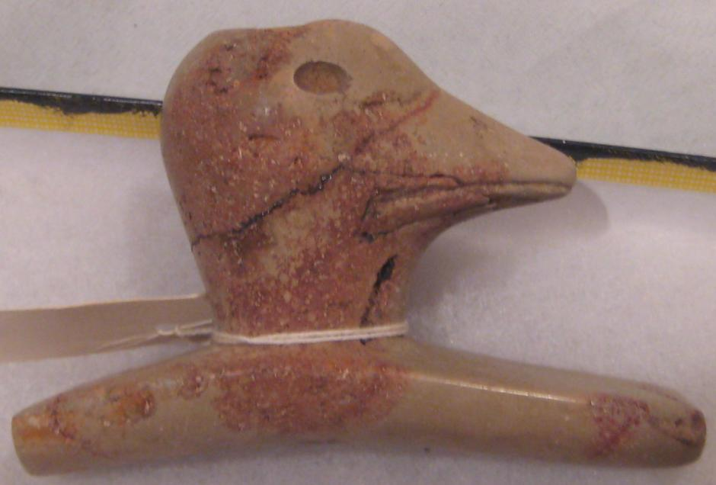

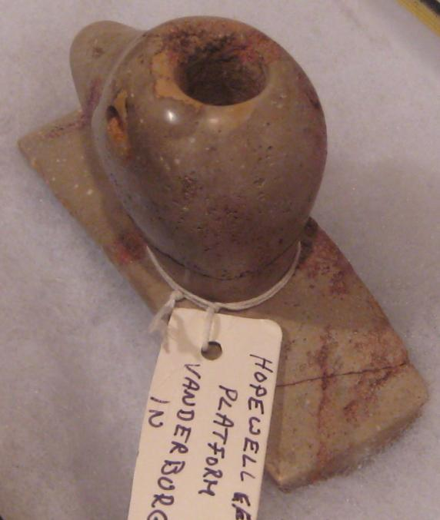

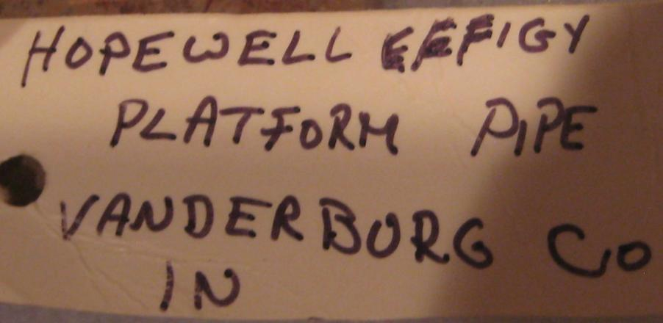

Figs. 1-4. US-IN-Vanderburg Co.-Pipe-Duck Effigy Platform-Sterling Pipestone, IL, Hopewell-c 50 CE

Case no.: 11

Accession Number:

Formal Label: US-IN-Vanderburg Co.-Pipe-Duck Effigy Platform-Sterling Pipestone, IL, Hopewell-c 50 CE

**Display Description:**

Hopewell duck effigy platform pipe, Vanderburg County, Indiana, ca second century CE, of Sterling Co. IL Pipestone, 3.00 in. wide x 4.50 in. long. This was found by Mrs. Mark Davis in 1929 in Vanderburgh County, Indiana. A similar pipe with a Merganser Duck's Head was also found by Mrs. Mark Davis in 1932 also in Vanderburgh County, Indiana. This time it was broken so Mrs. Davis met with Glen A. Black of the Department of Archaeology of the University of Indiana in 1937 who reassembled the broken pieces and made the following comment on it: “This is a clay-stone pipe made to resemble a duck's head, formed on a curved base which is very fragile” (Hart, 1998: 202, Fig. 143). Gordon Hart elaborated on this pipe's placement within the Hopewellian pipe tradition as attests to the nearly identical description of this present pipe leading one to surmise they were made by the same Hopewellian craftsmen: "The curved base is definitely not of the thicker basic type of the early Illinois Hopewell pipes. This is definitely of the workmanship we see in pipes taken from the Tremper, Hopewell and Mound City mounds. The base has a tapered length of 4 inches by 1 3/4 inches of width and having a thickness of approximately 1/14 inch at each end. All three of the aforementioned mounds were carbon dated within the first hundred years following B.C." (Hart, 1998: 202).

**LC Classification: E99.H69**

Date or Time Horizon: c 50 CE

Geographical Area: IN-Vanderburg Co.

**Map:**

**GPS coordinates:**

Cultural Affiliation:

Medium: Sterling Co. IL, Pipestone, indicated as Nothwest IL, below

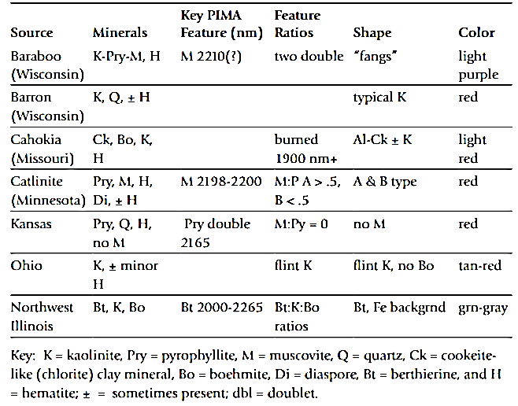

Mineral contents of Midwestern pipestones after Fishel, R.L., Wisseman, S.U., Hughes, R.E. and Emerson, T.E., 2010

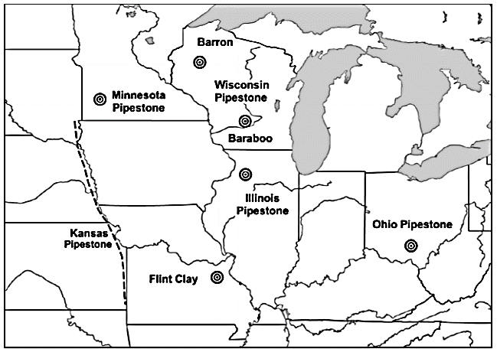

Map showing locations of pipestone sources after Fishel, R.L., Wisseman, S.U., Hughes, R.E. and Emerson, T.E., 2010. Sterling Co., IL, Pipestone is indicated as “Illinois Pipestone.”

Dimensions: W 3.00 in. x L 4.50 in. The base has a tapered length of 4 in. by 1 3/4 in. of width and having a thickness of approximately 1/14 in. at each end.

Weight:

Condition: original

Provenance: Mrs. Mark Davis in 1929 in Vanderburgh County, Indiana

**Discussion:**

The metaphoric significance of the duck effigy for the Hopewell people may pertain to the migratory specificity of the seasonal routes these birds take. The flight may signify the need to participate in seasonal Rendezvous with were deemed important not only for trade and exchange of goods but also of genes as well when young people of marriageable age could seal their vows and start their own families.

**References:**

Hart, Gordon. 1998. Hart's prehistoric pipe rack, vol. 2: Prehistoric pipes of the Mississippi River waterways--East, Bluffton, IN: Hart Publishers.

|  |
| --- |
| **Ralph J Coffman Jr**  149 Atlantic Ave  Swampscott MA 01907-2427  United States |

## Order details

|  |  |  |  |
| --- | --- | --- | --- |
| **Item title** | **Available actions** | **Shipping & handling (estimated delivery*)** | **Price** |

[Printer version](http://payments.ebay.com/ws/eBayISAPI.dll?ViewPaymentStatus&transid=363943648022&userloginid=802-867&printerversion=true&itemid=350620314833)

|  |  |  |
| --- | --- | --- |
| Seller: | [**Member id** woeltje_antiques](http://myworld.ebay.com/woeltje_antiques) ( [**Feedback Score Of** 587](http://feedback.ebay.com/ws/eBayISAPI.dll?ViewFeedback&userid=woeltje_antiques)) | [Contact seller](http://contact.ebay.com/ws/eBayISAPI.dll?ShowCoreAskSellerQuestion&frm=3998&iid=350620314833&redirect=0&requested=woeltje_antiques) |

|  |  |  |  |  |
| --- | --- | --- | --- | --- |
| Paid on Oct-21-12 via PayPal | | | | |
|  |  |  |  |  |

|  |  |  |  |  |  |  |  |  |
| --- | --- | --- | --- | --- | --- | --- | --- | --- |
|  | [**Item Title:**HOPEWELL EFFIGY PLATFORM PIPE.....COLLECTOR PIECE**- opens in a new window or tab**](http://cgi.ebay.com/ws/eBayISAPI.dll?ViewItem&item=350620314833)  **Item Id:**350620314833 - Price: US $375.00  Quantity:1  Having a problem with this purchase? [We can help](javascript:;) | |  | | --- | |  | | |  |  | | --- | --- | | [Leave feedback](http://feedback.ebay.com/ws/eBayISAPI.dll?LeaveFeedbackShow&useridfrom=802-867&useridto=woeltje_antiques&item=350620314833&transactid=363943648022) |  | | | Standard Shipping : **US $8.95**  USPS First Class Package®  Estimated delivery on or before Thu. Oct. 25 | US $375.00 |



|  |  |  |  |  |
| --- | --- | --- | --- | --- |
|  | | |  | |
|  |  | |  |  |  |  |  |  |  |  |  |  |  |  |  |  |  |  |  |  | | --- | --- | --- | --- | --- | --- | --- | --- | --- | --- | --- | --- | --- | --- | --- | --- | --- | --- | | |  | | --- | | |  |  |  |  |  |  |  |  |  |  |  |  |  |  |  | | --- | --- | --- | --- | --- | --- | --- | --- | --- | --- | --- | --- | --- | --- | --- | | |  |  | | --- | --- | | Subtotal: | US $375.00 | |  | | | Shipping & handling: | US $8.95 | |  | | |  | | |  | | | Total: | US $383.95 | | | | | |  |